Acceptance Test Procedure

Results (SKYDOC-XXXX)

For

Skyryse Flight OS LEMA TPX 325

Software Version: 19189000.9.2.109

|  |  |  |  |  |
| --- | --- | --- | --- | --- |
| LEMA Assembly Part Number | Operator | Condition | Serial Number | Test Start Time |
|  | Sam D | Factory Built | 003 | 3/6/2023 1:16:53 PM |

|  |  |  |
| --- | --- | --- |
| **Full test results:** | **Fail** | |
|  | | |
| **Group** | **Pass/Fail** | |
| **6.1. Visual Examination of the Product** | Pass | |
| **6.2 Weight** | Pass | |
| 6.3 Bonding | Fail | |
| **6.4 Resistance** and Inductance Test **(motor and solenoid)** | Fail | Fail |
| **6.5 Power ON UUT Checks** | Pass | |
| **6.6 Functional Check Out** | Pass | |
| **6.6.3 Holding Load Test** | Fail | Fail |
| **6.6.4 Brake Release Test** | Pass | |
| **6.6.5 N1 and N2 Extend Mechanical Stops and MCE Rigging** | Fail | |
| **6.6.6 N1 and N2 Stroke Check** | Fail | |
| **6.6.7 Performance Test – unloaded operation (one channel operation)** | Fail | |
| **6.6.8 Performance Test – Loaded Operation** | Fail | |
| **6.6.9 Backlash** | Fail | |

**6.1. Visual Examination of the Product**

|  |  |
| --- | --- |
| UUT conforms to the requirements of paragraph 6.1 | Pass |

**6.2 Weight**

|  |  |  |
| --- | --- | --- |
| UUT weight should not exceed 10 lbs | actual weight 10 lbs | Unhandled Type: Void |

6.3 Bonding

**Bonding resistance:**

|  |  |  |  |  |  |
| --- | --- | --- | --- | --- | --- |
| **Requirements** | | | **Results** | | |
|  | **Expected** | **Tolerance** | **Simplex** | **Duplex** | **Units** |
| Motor End Cap | 10 | 0.5 | 0 | 0 | (mOhms) |
| Solenoid housing | 10 | 0.5 | 0 | 0 | (mOhms) |
| Encoder cover | 7.5 | 0.5 | 0 | 0 | (mOhms) |
| All Bonding Pass/Fail | | | Fail | | |

**6.4 Resistance and Inductance Test** **(motor and solenoid)**

**Resistances:**

|  |  |  |  |  |  |  |
| --- | --- | --- | --- | --- | --- | --- |
| **Requirements** | | | **Results** | | | |
| Pins | **Expected** | **Tolerance** | **Connector J1** | **Connector J2** | **Connector J3** | **Units** |
| E to F | 0.212 mOhms | 0.0212 Ohms | 0 Ohms | 0 Ohms | 0 Ohms | (Ohms) |
| F to G | 0.212 mOhms | 0.0212 Ohms | 0 Ohms | 0 Ohms | 0 Ohms | (Ohms) |
| G to E | 0.212 mOhms | 0.0212 Ohms | 0 Ohms | 0 Ohms | 0 Ohms | (Ohms) |
| A to L | 6.55 mOhms | 0.44 Ohms | 0 Ohms | 0 Ohms | 0 Ohms | (Ohms) |
| G,F,E,A,L tied together to chassis grounds. Apply 500VDC | 5000000 mOhms | 0 Ohms | 0 Ohms | 0 Ohms | 0 Ohms | (Ohms) |
| All Resistances Pass/Fail | | | Fail | | | |

**Inductances:**

|  |  |  |  |  |  |  |  |
| --- | --- | --- | --- | --- | --- | --- | --- |
| **Requirements** | | | | **Results** | | | |
|  | | **Expected** | **Tolerance** | **Connector J1** | **Connector J2** | **Connector J3** | **Units** |
| E to F | 0.155 | | 0.02325 | 0 | 0 | 0 | (mH) |
| F to G | 0.155 | | 0.02325 | 0 | 0 | 0 | (mH) |
| G to E | 0.155 | | 0.02325 | 0 | 0 | 0 | (mH) |
| A to L | 22 | | 3.3 | 0 | 0 | 0 | (mH) |
| All Inductances Pass/Fail | | | | Fail | | | |

**6.5 Power ON UUT Checks**

Confirm all sensors are reporting nominal values and no faults reported

|  |  |  |  |
| --- | --- | --- | --- |
| **Description** | **Results** | | |
| **Sensor** | **Value** | **Units** | **Pass/Fail** |
| Motor 1 | -0 | Inches | Pass |
| Motor 2 | 0 | Inches | Pass |
| Motor 3 | -0.0031 | Inches | Pass |
| M1 | 0 | Inches | Pass |
| M2 | 0 | Inches | Pass |
| M3 | 0 | Inches | Pass |
| Faults 1 | 1024 | Code | Pass |
| Faults 2 | 1024 | Code | Pass |
| Faults 3 | 1024 | Code | Pass |

**6.6 Functional Check Out**

**6.6.1 MCE1, MCE 2, MCE3 Power Up**

|  |  |  |  |  |
| --- | --- | --- | --- | --- |
| **Requirements** | **Results** | | | |
| **Description** | **Ballnut position** | **Units** | **Pass/Fail** | |
| MCE 1 reports values for Ballnut position and motor current | 0 | Inches | Ballnut Position | Current |
| Pass | Pass |
| (Simulated) FCC/reports values for M1(QPS) | -0 | Inches | Pass |  |
| MCE 2 reports values for Ballnut position and motor current | 0 | Inches | Pass | Pass |
| (Simulated) FCC/reports values for M2(QPS) | -0 | Inches | Pass |  |
| MCE 3 reports values for Ballnut position and motor current | -0.0048 | Inches | Pass | Pass |
| (Simulated) FCC/reports values for M3(QPS) | -0 | Inches | Pass |  |

**6.6.3 Holding Load Test**

**6.6.3.1 Brake OFF, LEMA Output Locked**

|  |  |  |  |  |  |
| --- | --- | --- | --- | --- | --- |
| **Requirements** | | **Results** | | | |
| MCE | Expected Output force | Actual Output force | Units | Output force, Pass/Fail | Position feedback signals (all sensors) Pass/Fail |
| MCE 1, 6.6.3.1.1 step d/e– extend 0.2 in Sustain 12.6 Amps (TBC) current limit for 3-5 seconds | 325-800 | -258.9238 | lbf | Failed | RESULTS |
| MCE 1, 6.6.3.1.1 step f/g - retract 0.2 in Sustain 12.6 Amps (TBC) current limit for 3-5 seconds | 325-800 lbf | 278.6116 | lbf | Failed | RESULTS |
| MCE 2, 6.6.3.1.2 step d/e– extend 0.2 in Sustain 12.6 Amps (TBC) current limit for 3-5 seconds | 325-800 lbf | -233.1626 | lbf | Failed | RESULTS |
| MCE 2, 6.6.3.1.2 step f/g - retract 0.2 in Sustain 12.6 Amps (TBC) current limit for 3-5 seconds | 325-800 lbf | 249.039 | lbf | Failed | RESULTS |
| MCE 3, 6.6.3.1.3 step d/e– extend 0.2 in Sustain 12.6 Amps (TBC) current limit for 3-5 seconds | 325-800 lbf | -227.0596 | lbf | Failed | RESULTS |
| MCE 3, 6.6.3.1.3 step f/g - retract 0.2 in Sustain 12.6 Amps (TBC) current limit for 3-5 seconds | 325-800 lbf | 243.0309 | lbf | Failed | RESULTS |

**6.6.3.2 Brake ON, LEMA Output Free**

|  |  |  |  |  |  |  |
| --- | --- | --- | --- | --- | --- | --- |
| **Requirements** | **Results** | | | | | |
| **12.6 +- TBD Amps for 3-5 sec** | | | |  | | |
| **MCE** | **MCE Current** | **Units** | **Current Pass/Fail** | **Position feedback** | **Units** | **Position Feedback Pass/Fail** |
| MCE 1, 6.7.8.2.1 step I – extend 0.2 in | 6.0049 | A | Pass | -0.5556 | Inches | Pass |
| MCE 1, 6.7.8.2.1 step k - retract 0.2 in | -6.003 | A | True | -0.558 | Inches | Pass |
| MCE 2, 6.7.8.2.2 6.7.8.2.3 step i – extend 0.2 in | 6.0097 | A | True | -0.5603 | Inches | Failed |
| MCE 2, m step k - retract 0.2 in | -6.0084 | A | True | -0.5603 | Inches | Failed |
| MCE 3 m step i– extend 0.2 in | 5.9929 | A | True | -0.5611 | Inches | Failed |
| MCE 3 m step k - retract 0.2 in | -6.0076 | A | True | -0.5619 | Inches | Failed |

**6.6.4 Brake Release Test**

**Step d –** LEMA reaches commanded position

|  |  |  |  |  |  |
| --- | --- | --- | --- | --- | --- |
| **Requirements** | | | **Results** | | |
| Description | Expected | Tolerance | Position | Units | Pass/Fail |
| MCE1 /Motor 1 | 0.2 |  | 0.3999 | Inches | Failed |
| MCE2 /Motor 2 | 0.2 |  | 0.3999 | Inches | Failed |
| MCE3 /Motor 3 | 0.2 |  | 0.1859 | Inches | Pass |

**6.6.5 N1 and N2 Extend Mechanical Stops and MCE Rigging**

**Step 6.6.5.1** **Extend using M1/N1**

|  |  |  |  |
| --- | --- | --- | --- |
| **Requirements** | **Results** | | |
| **Description** | **Value** | **Units** | **Pass/Fail** |
| N1 extend stop engaged (M1 current saturated) | 1024 | Code | Pass |
| MCE 1 Motor Current 4.5 +/- 0.15 Amps | 5.9913 Amps | Amps | Failed |
| Linear Encoder Value | -0.484 | Inches | Pass |
| N1 is Rigged | 0 | Code | Pass |

**Step 6.6.5.2** **Extend using M2/N2**

|  |  |  |  |
| --- | --- | --- | --- |
| **Requirements** | **Results** | | |
| **Description** | **Value** | **Units** | **Pass/Fail** |
| N2 extend stop engaged (M2 current saturated) | 1024 | Code | Pass |
| MCE2 Motor Current 4.5 +/- 0.15 Amps | 6.0021 Amps | Amps | Failed |
| Linear Encoder Value | -0.4179 | Inches | Pass |
| N2 (Motor 2) is Rigged | 0 | Code | Pass |
| N2 (Motor 3) is Rigged | 0 | **Units** | Pass |

**6.6.6 N1 and N2 Stroke Check**

|  |  |  |  |
| --- | --- | --- | --- |
| **Requirements** | **Results** | | |
| **Pin to pin Length is 16.732 +/- TBD (ins)** | **Pin to Pin Length** | **Units** | **Pass/Fail** |
|  | Inches |  |
| **Description** | **Actual Position N1/N2** |  | **Pass/Fail** |
| N2 at -0.575 ins from Null using M2 | -0.575 | Inches | Pass |
| N1 at +1.725 ins from Null using M1 | 1.725 | Inches | Pass |
| N1 at -0.575 ins from Null using M1 | -0.575 | Inches | Pass |
| N2 at +1.725 ins from NULL using M2 | 1.725 | Inches | Pass |
| N1 at -0.575 ins from Null using M1 | -0.575 | Inches | Pass |
| N2 at +1.725 ins from Null using M3 | 1.725 | Inches | Pass |
| N2 at -0.575 ins from Null using M3 | -0.5737 | Inches | Pass |

MOTOR 1

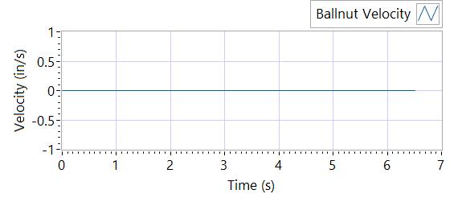

Figure - Ballnut Velocity for Motor One

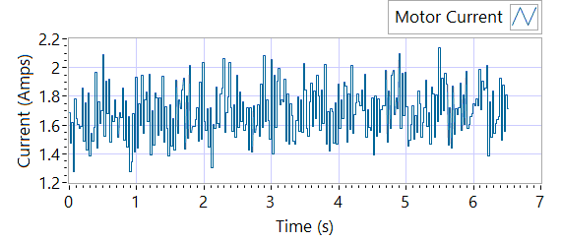

Figure -Current for Motor One

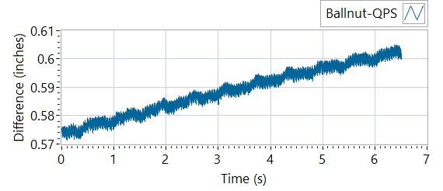

Figure - M1 Delta for Motor One

|  |  |  |  |  |  |  |
| --- | --- | --- | --- | --- | --- | --- |
| **Requirements** | | | **Results** | | | |
| **Description** | **Expected** | **Tolerance** | **Actual Average** | **Peak Velocity** | **Units** | **Pass/Fail** |
| Constant Velocity | 0.2 | 0.02 | 0 | 0 | In/s | Failed |
| **Description** | **Expected** | **Tolerance** | **Actual** | **Standard Deviation** | **Units** | **Pass/Fail** |
| Delta between Motor 1 Position and M1 position | 0.1 | 0.2 | 1.5986 | 0.0086 | Inches | Failed |
| Delta between Motor 1 Position and Linear Encoder position | 0.1 | 0.2 | 0.6051 | 0.376 | Inches | Failed |
| Motor Current |  |  | 1.6915 | 0.1752 | Amps |  |

|  |  |  |  |  |  |
| --- | --- | --- | --- | --- | --- |
| **Requirements** | | | **Results** | | |
| **Description** | **Expected Difference from Test rig encoder** | **Tolerance** | **Difference from Test rig encoder** | **Units** | **Pass/Fail** |
| Motor 1 position + Motor 2 position = test rig encoder | 0 | 0.1 | 0.0137 | Inches | Pass |
| Motor1 position + Motor 3 position = test rig encoder | 0 | 0.1 | 0.0137 | Inches | Pass |
| M1 position + M2 position = test rig encoder | 0.1 | 0.1 | -0.3605 | Inches | Failed |
| M1 position + M3 position = test rig encoder | 0 | 0.1 | -0.3606 | Inches | Failed |
| Difference between Motor 2 position and Motor 3 position is < TBD ins | 0 | 0.1 | 0 | Inches | Pass |
| Difference between M2 position and M3 position is < TBD ins | 0 | 0 | 0 | Inches | Pass |
| Difference between Motor 1 position and M1 position is < TBD ins | 0 | 0.1 | 0.9493 | Inches | Failed |
| Difference between Motor 2 position and M2 position is < TBD ins | 0 | 0.1 | 0.575 | Inches | Failed |
| Difference between Motor 3 position and M3 position is < TBD ins | 0 | 0.1 | 0.575 | Inches | Failed |

MOTOR 2

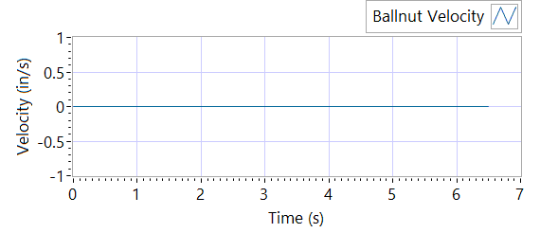

Figure - Ballnut Velocity for Motor Two

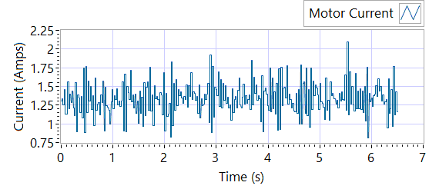

Figure -Current for Motor Two

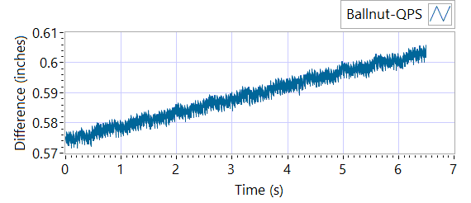

Figure - M1 Delta for Motor Two

|  |  |  |  |  |  |
| --- | --- | --- | --- | --- | --- |
| **Requirements** | | | **Results** | | |
| **Description** | **Expected Difference from Test rig encoder** | **Tolerance** | **Difference from Test rig encoder** | **Units** | **Pass/Fail** |
| Motor 1 position + Motor 2 position = test rig encoder | 0 | 0.1 | 0.0139 | Inches | Pass |
| Motor1 position + Motor 3 position = test rig encoder | 0 | 0.1 | 0.0139 | Inches | Pass |
| M1 position + M2 position = test rig encoder | 0.1 | 0.1 | -0.3461 | Inches | Failed |
| M1 position + M3 position = test rig encoder | 0 | 0.1 | -0.3461 | Inches | Failed |
| Difference between Motor 2 position and Motor 3 position is < TBD ins | 0 | 0.1 | 0.0012 | Inches | Pass |
| Difference between M2 position and M3 position is < TBD ins | 0 | 0 | 0 | Inches | Pass |
| Difference between Motor 1 position and M1 position is < TBD ins | 0 | 0.1 | 0.575 | Inches | Failed |
| Difference between Motor 2 position and M2 position is < TBD ins | 0 | 0.1 | 0.935 | Inches | Failed |
| Difference between Motor 3 position and M3 position is < TBD ins | 0 | 0.1 | 0.935 | Inches | Failed |

|  |  |  |  |  |  |  |
| --- | --- | --- | --- | --- | --- | --- |
| **Requirements** | | | **Results** | | | |
| **Description** | **Expected** | **Tolerance** | **Actual Average** | **Peak Velocity** | **Units** | **Pass/Fail** |
| Constant Velocity | 0.2 | 0.02 | 0 | 0 | In/s | Failed |
| **Description** | **Expected** | **Tolerance** | **Actual** | **Standard Deviation** | **Units** | **Pass/Fail** |
| Delta between Motor 2 Position and M2 position | 0.1 | 0.2 | 1.5987 | 0.0085 | Inches | Failed |
| Delta between Motor 2 Position and Linear Encoder position | 0.1 | 0.2 | 0.6054 | 0.3755 | Inches | Failed |
| Motor Current |  |  | 1.3388 | 0.2155 | Amps |  |

MOTOR 3

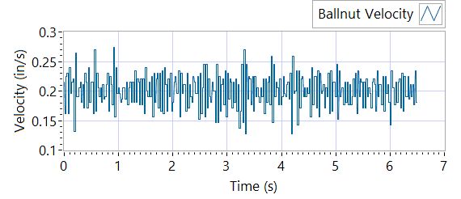

Figure - Ballnut Velocity for Motor Three

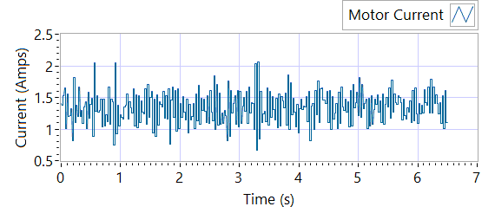

Figure -Current for Motor Three



Figure - M3 Delta for Motor Three

|  |  |  |  |  |  |  |
| --- | --- | --- | --- | --- | --- | --- |
| **Requirements** | | | **Results** | | | |
| **Description** | **Expected** | **Tolerance** | **Actual Average** | **Peak Velocity** | **Units** | **Pass/Fail** |
| Constant Velocity | 0.2 | 0.02 | 0.2007 | 0.2741 | In/s | Failed |
| **Description** | **Expected** | **Tolerance** | **Actual** | **Standard Deviation** | **Units** | **Pass/Fail** |
| Delta between Motor 3 Position and M3 position | 0.1 | 0.2 | 1.585 | 0.0086 | Inches | Failed |
| Delta between Motor 3 Position and Linear Encoder position | 0.1 | 0.2 | 0.6059 | 0.3753 | Inches | Failed |
| Motor Current |  |  | 1.3396 | 0.2494 | Amps |  |

|  |  |  |  |  |  |
| --- | --- | --- | --- | --- | --- |
| **Requirements** | | | **Results** | | |
| **Description** | **Expected Difference from Test rig encoder** | **Tolerance** | **Difference from Test rig encoder** | **Units** | **Pass/Fail** |
| Motor 1 position + Motor 2 position = test rig encoder | 0 | 0.1 | 0.0137 | Inches | Pass |
| Motor1 position + Motor 3 position = test rig encoder | 0 | 0.1 | 0.0138 | Inches | Pass |
| M1 position + M2 position = test rig encoder | 0.1 | 0.1 | -0.3616 | Inches | Failed |
| M1 position + M3 position = test rig encoder | 0 | 0.1 | -0.3616 | Inches | Failed |
| Difference between Motor 2 position and Motor 3 position is < TBD ins | 0 | 0.1 | 0.0014 | Inches | Pass |
| Difference between M2 position and M3 position is < TBD ins | 0 | 0 | 0 | Inches | Pass |
| Difference between Motor 1 position and M1 position is < TBD ins | 0 | 0.1 | 0.575 | Inches | Failed |
| Difference between Motor 2 position and M2 position is < TBD ins | 0 | 0.1 | 0.9503 | Inches | Failed |
| Difference between Motor 3 position and M3 position is < TBD ins | 0 | 0.1 | 0.9504 | Inches | Failed |

**6.6.7 Performance Test – unloaded operation (one channel operation)**

**6.6.7.1.1 MCE 1 - Step Response Test**

**The result for motor one is shown below:**

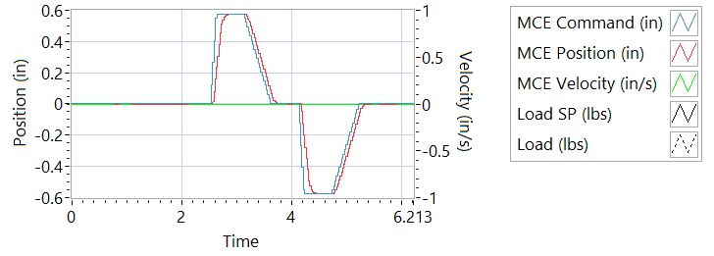

Figure - Results for Motor One

**Step d Extension**

|  |  |  |  |
| --- | --- | --- | --- |
| **Requirements** | **Results** | | |
| **Description** | **Actual Speed / Time** | **Units** | **Pass/Fail** |
| No Load speed is 2.7 to 3.3 in/sec | 3.264 | In/s | True |
| Time to achieve 80% of the specified stroke (+ 0.575 ins) is 170+9/-9 ms seconds | 205 | miliseconds | Failed |

**Step e Retraction**

|  |  |  |  |
| --- | --- | --- | --- |
| **Requirements** | **Results** | | |
| **Description** | **Actual Speed / Time** | **Units** | **Pass/Fail** |
| No Load speed is 2.7 to 3.3 in/sec | -3.2049 | In/s | Failed |
| Time to achieve 80% of the specified stroke (- 0.575 ins) is 170+9/-9 ms seconds | 197 | miliseconds | Failed |

**6.6.7..1.2 MCE 1 - Frequency Response**

**Step d**

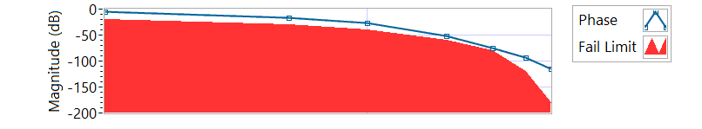

Figure - Phase for Motor One

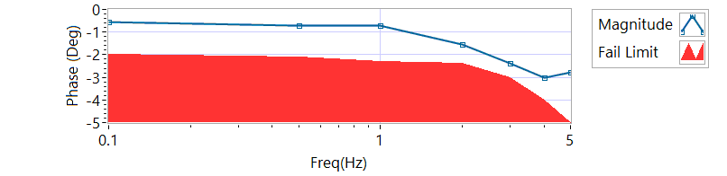

Figure - Magnitude for Motor One

**Frequency Response**

|  |  |  |  |  |
| --- | --- | --- | --- | --- |
| **Frequency**  **(Hz)** | **Magnitude**  **(dB)** | **Phase**  **(deg)** | **Max Phase**  **Allowance (deg)** | **Pass/Fail** |
| 0.1 Hz | -0.56957 | -5.5296 | -20 | Pass |
| 0.5 Hz | -0.71679 | -16.11 | -30 | Pass |
| 1 Hz | -0.71679 | -27.468 | -40 | Pass |
| 2 Hz | -1.55802 | -51.48 | -60 | Pass |
| 3 Hz | -2.3804 | -75.168 | -80 | Pass |
| 4 Hz | -3.02926 | -93.888 | -120 | Pass |
| 5 Hz | -2.79428 | -115.56 | -180 | Pass |

6.6.7.2.1 **MCE 2 - Step Response Test**

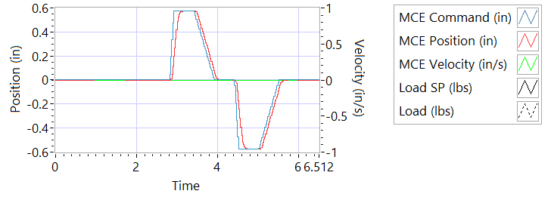

Figure - Results for Motor Two

**Step d Extension**

|  |  |  |  |
| --- | --- | --- | --- |
| **Requirements** | **Results** | | |
| **Description** | **Actual Speed / Time** | **Units** | **Pass/Fail** |
| No Load speed is 2.7 to 3.3 in/sec | 3.2282 | In/s | Pass |
| Time to achieve 80% of the specified stroke (+ 0.575 ins) is 170+9/-9 ms seconds | 210 | milliseconds | Failed |

**Step e Retraction**

|  |  |  |  |
| --- | --- | --- | --- |
| **Requirements** | **Results** | | |
| **Description** | **Actual Speed / Time** | **Units** | **Pass/Fail** |
| No Load speed is 2.7 to 3.3 in/sec | -3.1416 | In/s | Failed |
| Time to achieve 80% of the specified stroke (- 0.575 ins) is 170+9/-9 ms seconds | 200 | milliseconds | Failed |

6.6.7.2.2 **MCE 2 - Frequency Response Test**

**Step d**

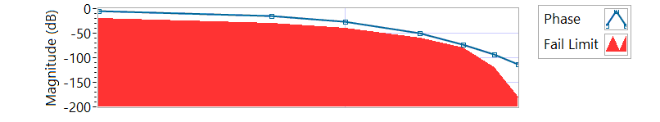

Figure - Phase for Motor Two

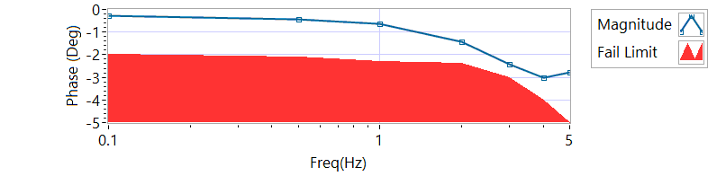

Figure - Magnitude for Motor Two

**Frequency Response**

|  |  |  |  |  |
| --- | --- | --- | --- | --- |
| **Frequency (Hz)** | **Magnitude**  **(db)** | **Phase**  **(Deg)** | **Max Phase**  **Allowance (Deg)** | **Pass/Fail** |
| 0.1 Hz | -0.282405 | -4.7448 | -20 | Pass |
| 0.5 Hz | -0.424798 | -15.138 | -30 | Pass |
| 1 Hz | -0.628155 | -26.892 | -40 | Pass |
| 2 Hz | -1.41203 | -50.544 | -60 | Pass |
| 3 Hz | -2.43498 | -73.44 | -80 | Pass |
| 4 Hz | -3.00926 | -93.168 | -120 | Pass |
| 5 Hz | -2.76275 | -113.94 | -180 | Pass |

6.6.7.3.1 **MCE 3 – Step Response Test**

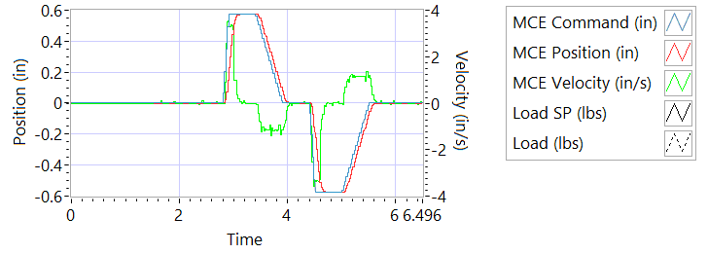

Figure - Results for Motor Three

**Step d Extension**

|  |  |  |  |
| --- | --- | --- | --- |
| **Requirements** | **Results** | | |
| **Description** | **Actual Speed / Time** | **Units** | **Pass/Fail** |
| No Load speed is 2.7 to 3.3 in/sec | 3.1886 | In/s | Pass |
| Time to achieve 80% of the specified stroke (+ 0.575 ins) is 170+9/-9 ms seconds | 217 | milliseconds | Failed |

**Step e Retraction**

|  |  |  |  |
| --- | --- | --- | --- |
| **Requirements** | **Results** | | |
| **Description** | **Actual Speed / Time** | **Units** | **Pass/Fail** |
| No Load speed is 2.7 to 3.3 in/sec | -3.2063 | In/s | Failed |
| Time to achieve 80% of the specified stroke (- 0.575 ins) is 170+9/-9 ms seconds | 212 | milliseconds | Failed |

6.6.7.3.2 **MCE 3 Frequency Response Test**

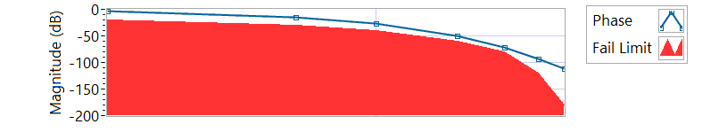

Figure - Phase for Motor Three

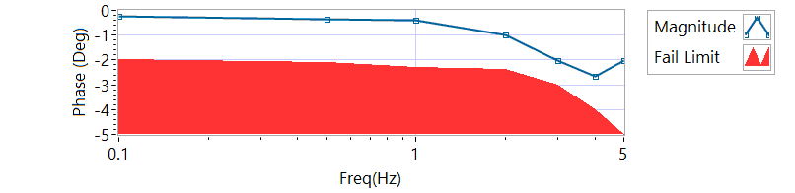

Figure - Magnitude for Motor Three

**Step d**

|  |  |  |  |  |
| --- | --- | --- | --- | --- |
| **Frequency**  **(Hz)** | **Magnitude**  **(dB)** | **Phase**  **(Deg)** | **Max Phase**  **Allowance (Deg)** | **Pass/Fail** |
| 0.1 Hz | -0.226092 | -3.4488 | -20 | Pass |
| 0.5 Hz | -0.353309 | -14.94 | -30 | Pass |
| 1 Hz | -0.410452 | -26.352 | -40 | Pass |
| 2 Hz | -0.988246 | -49.896 | -60 | Pass |
| 3 Hz | -2.0112 | -72.252 | -80 | Pass |
| 4 Hz | -2.67342 | -92.592 | -120 | Pass |
| 5 Hz | -2.02397 | -112.32 | -180 | Pass |

**6.6.8 Performance Test – Loaded Operation**

6.6.8.1 **Step and Frequency Response Test - Loaded**

6.6.8.1.1 **MCE1 – Step Response Test**

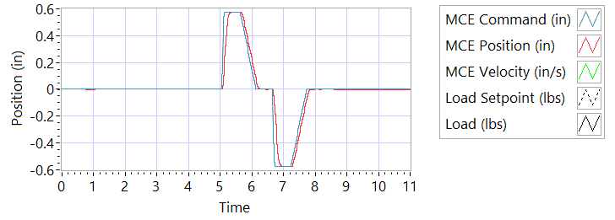

Figure - Results for Motor One Loaded

Step response Test

**Step j – 225 lbf tension - Extension**

|  |  |  |  |
| --- | --- | --- | --- |
| **Requirements** | **Results** | | |
| **Description** | **Actual Speed / Time** | **Units** | **Pass/Fail** |
| No Load speed is 2.7 to 3.3 in/sec | 3.1832 | In/s | Pass |
| Time to achieve 80% of the specified stroke (+ 0.575 ins) is 170+9/-9 ms seconds | 192 | milliseconds | Failed |

**Step k – 225 lbf tension - Retraction**

|  |  |  |  |
| --- | --- | --- | --- |
| **Requirements** | **Results** | | |
| **Description** | **Actual Speed / Time** | **Units** | **Pass/Fail** |
| No Load speed is 2.7 to 3.3 in/sec | -3.0994 | In/s | Failed |
| Time to achieve 80% of the specified stroke (- 0.575 ins) is 170+9/-9 ms seconds | 205 | milliseconds | Failed |

**Step n – 225 lbf compression - Extension**

|  |  |  |  |
| --- | --- | --- | --- |
| **Requirements** | **Results** | | |
| **Description** | **Actual Speed / Time** | **Units** | **Pass/Fail** |
| No Load speed is 2.7 to 3.3 in/sec | 3.1655 | In/s | Pass |
| Time to achieve 80% of the specified stroke (+0.575 ins) is 170+9/-9 ms seconds | 200 | milliseconds | Failed |

**Step o – 225 lbf compression - Retraction**

|  |  |  |  |
| --- | --- | --- | --- |
| **Requirements** | **Results** | | |
| **Description** | **Actual Speed / Time** | **Units** | **Pass/Fail** |
| No Load speed is 2.7 to 3.3 in/sec | -3.1625 | In/s | Failed |
| Time to achieve 80% of the specified stroke (-0.575 ins) is 170+9/-9 ms seconds | 192 | milliseconds | Failed |

6.6.8.1.2 **MCE 1 – Frequency Response Test**

**Step d – 225 lbf Tension**

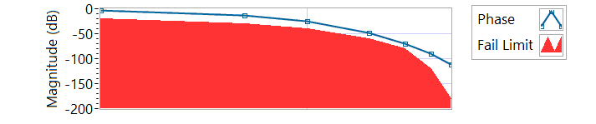

Figure - Phase for Motor One Loaded Tension

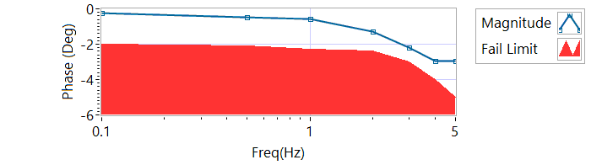

Figure - Magnitude for Motor One Loaded Tension

|  |  |  |  |  |
| --- | --- | --- | --- | --- |
| **Frequency**  **(Hz)** | **Magnitude**  **(dB)** | **Phase**  **(Deg)** | **Max Phase**  **Allowance (Deg)** | **Pass/Fail** |
| 0.1 HZ | -0.254203 | -4.14 | -20 | Pass |
| 0.5 HZ | -0.453561 | -13.608 | -30 | Pass |
| 1 HZ | -0.56957 | -25.488 | -40 | Pass |
| 2 HZ | -1.26846 | -48.744 | -60 | Pass |
| 3 HZ | -2.20287 | -69.552 | -80 | Pass |
| 4 HZ | -2.95002 | -89.568 | -120 | Pass |
| 5 HZ | -2.96377 | -110.88 | -180 | Pass |

**Step h – 225 lbf Compression**

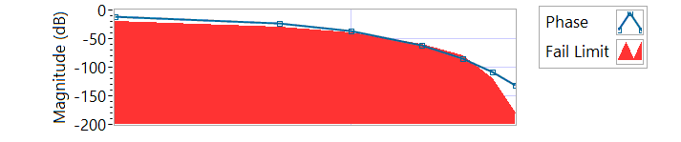

Figure - Phase for Motor One Loaded Compression

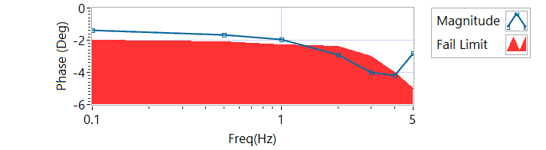

Figure - Magnitude for Motor One Loaded Compression

|  |  |  |  |  |
| --- | --- | --- | --- | --- |
| **Frequency**  **(Hz)** | **Magnitude**  **(dB)** | **Phase**  **(Deg)** | **Max Phase**  **Allowance (Deg)** | **Pass/Fail** |
| 0.1 HZ | -1.36391 | -11.592 | -20 | Pass |
| 0.5 HZ | -1.67328 | -23.382 | -30 | Pass |
| 1 HZ | -1.94263 | -36.504 | -40 | Pass |
| 2 HZ | -2.91879 | -61.056 | -60 | Failed |
| 3 HZ | -4.01272 | -85.428 | -80 | Failed |
| 4 HZ | -4.21009 | -108.864 | -120 | Pass |
| 5 HZ | -2.8286 | -131.76 | -180 | Pass |

6.6.8.2.1 **MCE 2 – Step Response Test**

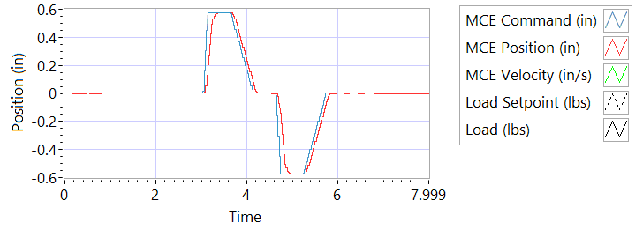

Figure - Results for Motor Two Loaded Tension

**Step j – 225 lbf tension - Extension**

|  |  |  |  |
| --- | --- | --- | --- |
| **Requirements** | **Results** | | |
| **Description** | **Actual Speed / Time** | **Units** | **Pass/Fail** |
| No Load speed is 2.7 to 3.3 in/sec | 3.2117 | In/s | Pass |
| Time to achieve 80% of the specified stroke (+ 0.575 ins) is 170+9/-9 ms seconds | 218 | milliseconds | Failed |

**Step k – 225 lbf tension - Retraction**

|  |  |  |  |
| --- | --- | --- | --- |
| **Requirements** | **Results** | | |
| **Description** | **Actual Speed / Time** | **Units** | **Pass/Fail** |
| No Load speed is 2.7 to 3.3 in/sec | -3.2274 | In/s | Failed |
| Time to achieve 80% of the specified stroke (- 0.575 ins) is 170+9/-9 ms seconds | 229 | milliseconds | Failed |

**Step n – 225 lbf compression - Extension**

|  |  |  |  |
| --- | --- | --- | --- |
| **Requirements** | **Results** | | |
| **Description** | **Actual Speed / Time** | **Units** | **Pass/Fail** |
| No Load speed is 2.7 to 3.3 in/sec | 3.2519 | In/s | Pass |
| Time to achieve 80% of the specified stroke (+0.575 ins) is 170+9/-9 ms seconds | 229 | milliseconds | Failed |

**Step o – 225 lbf compression - Retraction**

|  |  |  |  |
| --- | --- | --- | --- |
| **Requirements** | **Results** | | |
| **Description** | **Actual Speed / Time** | **Units** | **Pass/Fail** |
| No Load speed is 2.7 to 3.3 in/sec | -3.2098 | In/s | Failed |
| Time to achieve 80% of the specified stroke (-0.575 ins) is 170+9/-9 ms seconds | 218 | milliseconds | Failed |

6.6.8.2.2 **MCE 2 – Frequency response Test**

**Step d – 225 lbf Tension**

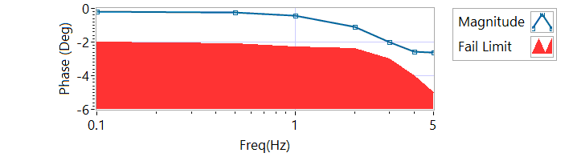

Figure - Magnitude for Motor Two Loaded Tension

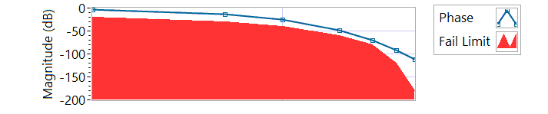

Figure - Phase for Motor Two Loaded Tension

|  |  |  |  |  |
| --- | --- | --- | --- | --- |
| **Frequency**  **(Hz)** | **Magnitude**  **(dB)** | **Phase**  **(Deg)** | **Max Phase**  **Allowance (Deg)** | **Pass/Fail** |
| 0.1 HZ | -0.184096 | -3.1284 | -20 | Pass |
| 0.5 HZ | -0.254203 | -12.69 | -30 | Pass |
| 1 HZ | -0.424798 | -24.696 | -40 | Pass |
| 2 HZ | -1.09615 | -48.24 | -60 | Pass |
| 3 HZ | -1.9768 | -70.416 | -80 | Pass |
| 4 HZ | -2.57606 | -91.728 | -120 | Pass |
| 5 HZ | -2.61887 | -111.96 | -180 | Pass |

**Step h – 225 lbf Compression**

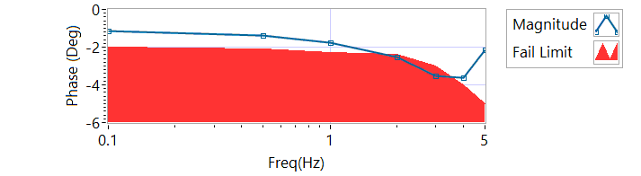

Figure - Magnitude for Motor Two Loaded Compression

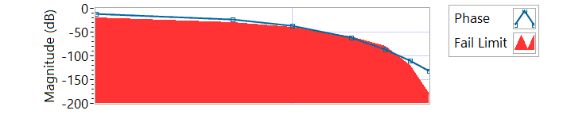

Figure - Phase for Motor Two Loaded Compression

|  |  |  |  |  |
| --- | --- | --- | --- | --- |
| **Frequency**  **(Hz)** | **Magnitude**  **(dB)** | **Phase**  **(Deg)** | **Max Phase**  **Allowance (Deg)** | **Pass/Fail** |
| 0.1 HZ | -1.12722 | -10.89 | -20 | Pass |
| 0.5 HZ | -1.37992 | -22.806 | -30 | Pass |
| 1 HZ | -1.75656 | -36.864 | -40 | Pass |
| 2 HZ | -2.52604 | -61.704 | -60 | Failed |
| 3 HZ | -3.54624 | -85.968 | -80 | Failed |
| 4 HZ | -3.61061 | -109.44 | -120 | Pass |
| 5 HZ | -2.15158 | -132.48 | -180 | Pass |

6.6.8.3.1 **MCE 3 – Step Response Test**

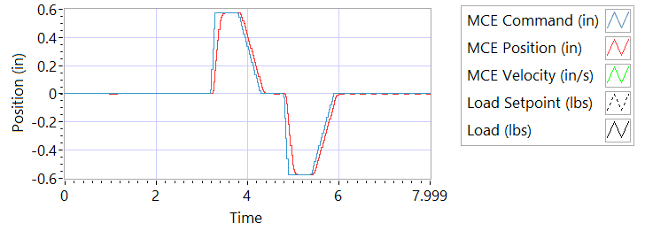

Figure - Results for Motor Three

**Step j – 225 lbf tension - Extension**

|  |  |  |  |
| --- | --- | --- | --- |
| **Requirements** | **Results** | | |
| **Description** | **Actual Speed / Time** | **Units** | **Pass/Fail** |
| No Load speed is 2.7 to 3.3 in/sec | 3.2306 | In/s | Pass |
| Time to achieve 80% of the specified stroke (+ 0.575 ins) is 170+9/-9 ms seconds | 228 | milliseconds | Failed |

**Step k – 225 lbf tension - Retraction**

|  |  |  |  |
| --- | --- | --- | --- |
| **Requirements** | **Results** | | |
| **Description** | **Actual Speed / Time** | **Units** | **Pass/Fail** |
| No Load speed is 2.7 to 3.3 in/sec | -3.2483 | In/s | Failed |
| Time to achieve 80% of the specified stroke (- 0.575 ins) is 170+9/-9 ms seconds | 224 | milliseconds | Failed |

**Step n – 225 lbf compression - Extension**

|  |  |  |  |
| --- | --- | --- | --- |
| **Requirements** | **Results** | | |
| **Description** | **Actual Speed / Time** | **Units** | **Pass/Fail** |
| No Load speed is 2.7 to 3.3 in/sec | 3.2059 | In/s | Pass |
| Time to achieve 80% of the specified stroke (+0.575 ins) is 170+9/-9 ms seconds | 218 | milliseconds | Failed |

**Step o – 225 lbf compression - Retraction**

|  |  |  |  |
| --- | --- | --- | --- |
| **Requirements** | **Results** | | |
| **Description** | **Actual Speed / Time** | **Units** | **Pass/Fail** |
| No Load speed is 2.7 to 3.3 in/sec | -3.12 | In/s | Failed |
| Time to achieve 80% of the specified stroke (-0.575 ins) is 170+9/-9 ms seconds | 213 | milliseconds | Failed |

6.6.8.3.2 **MCE 3 – Frequency Response Test**

**Step d – 225 lbf Tension**

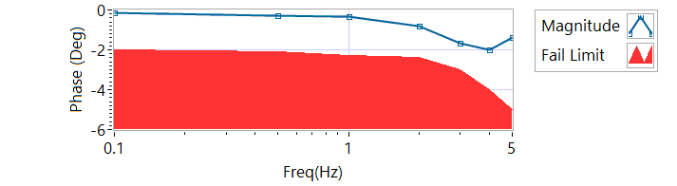

Figure - Magnitude for Motor Three Loaded Tension

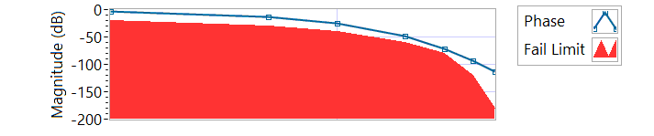

Figure - Phase for Motor Three Loaded Tension

|  |  |  |  |  |
| --- | --- | --- | --- | --- |
| **Frequency**  **(Hz)** | **Magnitude**  **(dB)** | **Phase**  **(Deg)** | **Max Phase**  **Allowance (Deg)** | **Pass/Fail** |
| 0.1 HZ | -0.156212 | -3.8052 | -20 | Pass |
| 0.5 HZ | -0.268291 | -13.194 | -30 | Pass |
| 1 HZ | -0.324875 | -24.912 | -40 | Pass |
| 2 HZ | -0.806337 | -48.384 | -60 | Pass |
| 3 HZ | -1.68977 | -71.172 | -80 | Pass |
| 4 HZ | -2.01422 | -92.592 | -120 | Pass |
| 5 HZ | -1.37303 | -113.04 | -180 | Pass |

**Step h – 225 lbf Compression**

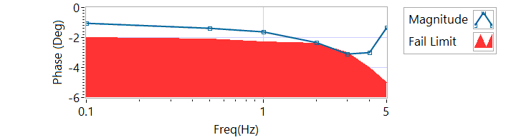

Figure - Magnitude for Motor Three Loaded Compression

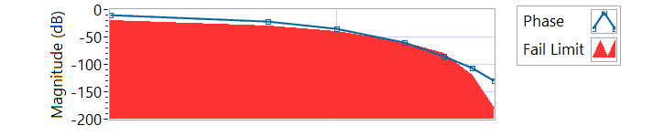

Figure - Phase for Motor Three Loaded Compression

|  |  |  |  |  |
| --- | --- | --- | --- | --- |
| **Frequency**  **(Hz)** | **Magnitude**  **(dB)** | **Phase**  **(Deg)** | **Max Phase**  **Allowance (Deg)** | **Pass/Fail** |
| 0.1 HZ | -1.06518 | -10.4364 | -20 | Pass |
| 0.5 HZ | -1.37992 | -22.302 | -30 | Pass |
| 1 HZ | -1.60722 | -35.676 | -40 | Pass |
| 2 HZ | -2.32718 | -59.904 | -60 | Pass |
| 3 HZ | -3.10748 | -84.348 | -80 | Failed |
| 4 HZ | -2.97688 | -107.28 | -120 | Pass |
| 5 HZ | -1.34426 | -130.5 | -180 | Pass |

**6.6.9 Backlash**

6.6.9.1 **Simplex Brake 1 – ON; Duplex brake 2 – OFF**

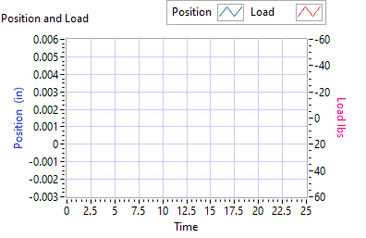

Figure - Backlash Simplex brake 1 On, Duplex brake 2 Off

|  |  |  |  |  |  |  |
| --- | --- | --- | --- | --- | --- | --- |
| **Requirements** | **Results** | | | | | |
| **Load (lbf)** | **Backlash (ins)** | | | **Units** | | **Pass/Fail** |
| Step e +/- 35 lbf tension (motor 2 and motor 3 ZERO position) | 0.0016 | | | Inches | | Pass |
| Step e +/- 25 lbf compression  (motor 2 and motor 3 ZERO position) | -0.0008 | | | Inches | | Pass |
| Step g,Total backlash  New units: 0.0144 ins  In Service Units: 0.019 ins | 0 | | | Inches | | Pass |
| **Requirements** | **Results** | | | | | |
| **All channels feedback signals remain within allowable limits** | **Allowable limit** | **Actual Value** | **Units** | | **Pass/Fail** | |
| Motor 1 Tension | 0.1000 | 0.0000 | Inches | | Pass | |
| Motor 1 Compression |  |  | Inches | |  | |
| Motor 2 Tension | 0.1000 | 0.0000 | Inches | | Pass | |
| Motor 2 Compression |  |  | Inches | |  | |
| Motor 3 Tension | 0.1000 | 0.0002 | Inches | | Pass | |
| Motor 3 Compression |  |  | Inches | |  | |
| M1 Tension | 0.1000 | 0.0000 | Inches | | Pass | |
| M1 Compression |  |  | Inches | |  | |
| M2 Tension | 0.1000 | -0.0043 | Inches | | Pass | |
| M2 Compression |  |  | Inches | |  | |
| M3 Tension | 0.1000 | -0.0094 | Inches | | Pass | |
| M3 Compression |  |  | Inches | |  | |

6.6.9.2**Simplex Brake 1 – OFF; Duplex Brake 2 – ON**

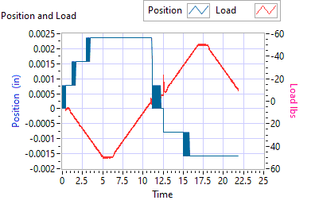

Figure - Backlash Simplex brake 1 Off, Duplex brake 2 On

|  |  |  |  |  |
| --- | --- | --- | --- | --- |
| **Requirements** | **Results** | | | |
| **Load (lbf)** | **Backlash (ins)** | | **Units** | **Pass/Fail** |
| Step e +/- 35 lbf tension  (motor 1 ZERO position) | 0.0024 | | Inches | Pass |
| Step e +/- 25 lbf compression  (motor 1 ZERO position) | -0.0016 | | Inches | Pass |
| Step g, Total backlash  New units: 0.0144 ins  In Service Units: 0.019 ins | 0.0008 | | Inches | Pass |
| **Requirements** | | **Results** | | |
| **All channels feedback signals remain within allowable limits** | **Allowable limit** | **Actual Value** | **Units** | **Pass/Fail** |
| Motor 1 Tension | 0.1000 | 0.0000 | Inches | Pass |
| Motor 1 Compression |  |  | Inches |  |
| Motor 2 Tension | 0.1000 | 0.0000 | Inches | Pass |
| Motor 2 Compression |  |  | Inches |  |
| Motor 3 Tension | 0.1000 | 0.0002 | Inches | Pass |
| Motor 3 Compression |  |  | Inches |  |
| M1 Tension | 0.1000 | 0.0000 | Inches | Pass |
| M1 Compression |  |  | Inches |  |
| M2 Tension | 0.1000 | -0.0043 | Inches | Pass |
| M2 Compression |  |  | Inches |  |
| M3 Tension | 0.1000 | -0.0094 | Inches | Pass |
| M3 Compression |  |  | Inches |  |

6.6.9.3 **Both Brakes OFF**

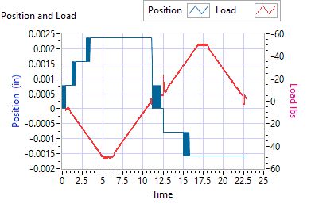

Figure - Backlash Simplex brake 1 Off, Duplex brake 2 Off

|  |  |  |  |  |
| --- | --- | --- | --- | --- |
| **Requirements** | **Results** | | | |
| **Load (lbf)** | **Backlash (ins)** | | Units | **Pass/Fail** |
| Step e +/- 35 lbf tension  (motor 1 and motor 2 holding ZERO position) | 0.0016 | | Inches | Pass |
| Step e +/- 25 lbf compression  (motor 1 and motor 2 holding ZERO position) | -0.0008 | | Inches | Pass |
| Step g,Total backlash  New units: 0.0144 ins  In Service Units: 0.019 ins | 0.0008 | | Inches | Pass |
| **Requirements** | **Results** | | | |
| **All channels feedback signals remain within allowable limits** | **Allowable**  **limit** | **Actual Value** | **Units** | **Pass/Fail** |
| Motor 1 Tension | 0.1000 | 0.0000 | Inches | Pass |
| Motor 1 Compression |  |  | Inches |  |
| Motor 2 Tension | 0.1000 | 0.0000 | Inches | Pass |
| Motor 2 Compression |  |  | Inches |  |
| Motor 3 Tension | 0.1000 | 0.0002 | Inches | Pass |
| Motor 3 Compression |  |  | Inches |  |
| M1 Tension | 0.1000 | 0.0000 | Inches | Pass |
| M1 Compression |  |  | Inches |  |
| M2 Tension | 0.1000 | -0.0043 | Inches | Pass |
| M2 Compression |  |  | Inches |  |
| M3 Tension | 0.1000 | -0.0094 | Inches | Pass |
| M3 Compression |  |  | Inches |  |